DistilBERT:
DistilBERT is the distilled version of BERT meaning it is trained using knowledge distillation a technique where smaller model(student) learns from larger model(teacher).
It retains 97% of BERT performance while being 40% smaller and 60% faster making it highly efficient for NLP tasks such as text classification , sentiment analysis and question-answering.
How DistilBERT works?:
DistilBERT uses knowledge distillation where the smaller model (student) learns to replicate the behaviour of larger model (teacher). This process involves training the student model to mimic the predictions and internal representations of the teacher model.
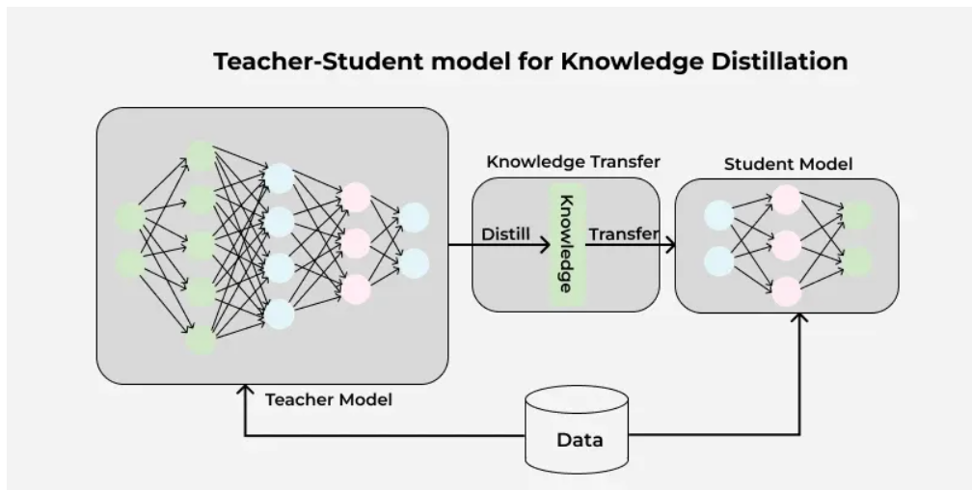
In the above diagram, The teacher model (BERT) is a large neural network with many parameters. The student model (DistilBERT) is a smaller network trained to replicate the teacher’s behaviour using knowledge transfer. The distillation process involves minimizing the difference between the teacher’s soft predictions and the student’s output allowing the student model to retain most of the teacher’s knowledge while being significantly smaller.

DistilBERT is trained using triple-loss function:
- Language Modeling loss – Predicts the next word in a sentence
- Distillation loss – Encourages the student model to mimic the teacher’s soft predictions.
- Cosine – Distance loss – Aligns the hidden state representation of the student and teacher models

Code:
from datasets import load_dataset
from transformers import AutoTokenizer
from transformers import AutoModelForSequenceClassification
from transformers import Trainer, TrainingArguments
import torch

dataset = load_dataset("imdb")
train_dataset, test_dataset = dataset['train'], dataset['test']

tokenizer = AutoTokenizer.from_pretrained("distilbert-base-uncased")

def preprocess_function(example):
return tokenizer(example['text'],truncation=True,padding=True,max_length=512)

tokenized_train = train_dataset.map(preprocess_function, batched=True)
tokenized_test = test_dataset.map(preprocess_function, batched=True)

model = AutoModelForSequenceClassification.from_pretrained("distilbert-base-uncased",num_labels=2)

training_args = TrainingArguments(
output_dir="./results",
eval_strategy="epoch",
learning_rate=2e-5,
per_device_train_batch_size=16,
per_device_eval_batch_size=16,
num_train_epochs=3,
weight_decay=0.01,
logging_dir='./logs',
logging_steps=10,
)

trainer = Trainer(
model=model,
args=training_args,
train_dataset=tokenized_train,
eval_dataset=tokenized_test,
)

trainer.train()

result = trainer.evaluate()
print(f"Evaluation Results:{result}")

device = torch.device("cuda" if torch.cuda.is_available() else "cpu")
model.to(device)

new_review = "This movie was fantastic! I loved every minute of it"
inputs = tokenizer(new_review, return_tensors="pt", truncation=True, padding=True, max_length=512)
inputs = {key: value.to(device) for key, value in inputs.items()}

outputs = model(**inputs)
predictions = torch.argmax(outputs.logits, dim=-1)
print("Positive" if predictions.item() == 1 else "Negative")

Bayes Theorem:
Bayes' Theorem is a mathematical formula used to determine the conditional probability of an event based on prior knowledge and new evidence. It adjusts probabilities when new information comes in and helps make better decision in uncertain situations.
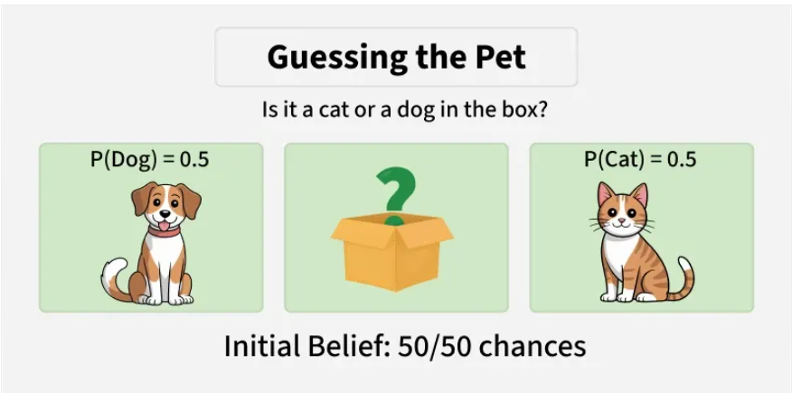
In this case, knowing that the pet is quiet (new information), we can use Bayes' Theorem to calculate the updated probability of the pet being a cat or a dog, based on how likely each animal is to be quiet.

Bayes Theorem or Bayes law or Bayes rules is used to determine the conditional probability of event A when event B has already occurred.

General Statement of Bayes’ Theorem:
“The conditional probability of event A, given the occurrence of event B, is equal to the product of the probability of B, given A and the probability of event A is divided by the probability of B”
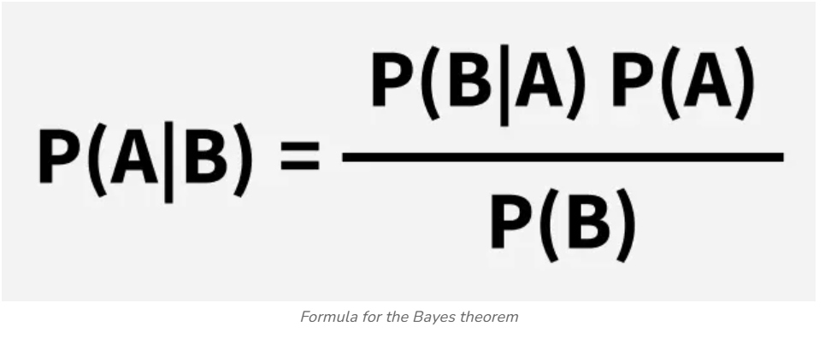
Where,
P(A) and P(B) are the probabilities of event A and event B, also P(B) is never equal to zero.
P(A|B) is the probability of event A when event B happens.
P(B|A) is the probability of event B when event A happens.

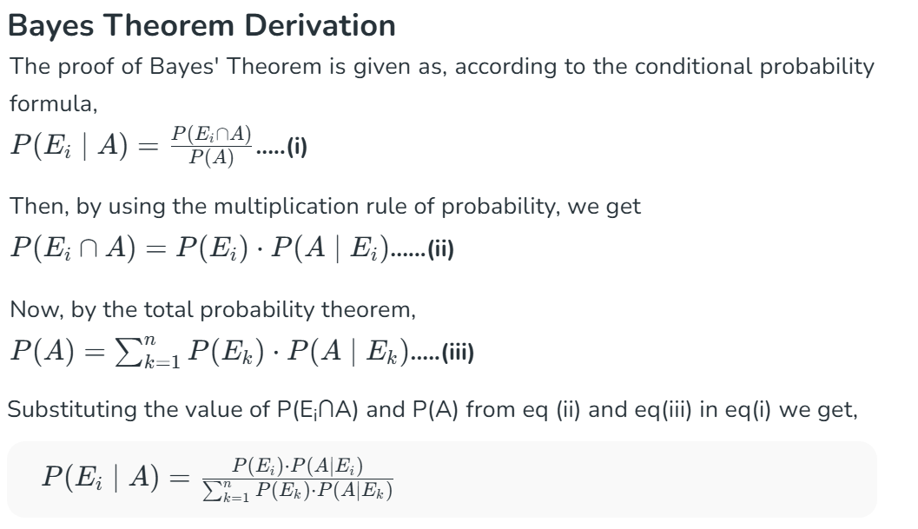
Let E₁, E₂,…, E_{n} be a set of events associated with the sample space S, in which all the events E₁, E₂,…, E_{n} have a non-zero probability of occurrence. All the events E₁, E₂,…, E form a partition of S. Let A be an event in space S for which we have to find the probability, then according to Bayes theorem.

Terms Related to Bayes’ Theorem:
Hypotheses
- Hypotheses refer to possible events or outcomes in the sample space; they are denoted as E₁, E₂, …, E_{n}.
- Each hypothesis represents a distinct scenario that could explain an observed event.

Priori Probability
- Priori Probability P(E_{i}) is the initial probability of an event occurring before any new data is taken into account.
- It reflects existing knowledge or assumptions about the event.
- Example: The probability of a person having a disease before taking a test.

Posterior Probability
- Posterior Probability (P(Ei∣A) is the updated probability of an event after considering new information.
- It is derived using the Bayes Theorem.
- Example: The probability of having a disease given a positive test result.

Conditional Probability
- The probability of an event A based on the occurrence of another event B is termed conditional Probability
- It is denoted as P(A|B) and represents the probability of A when event B has already happened.

Joint Probability
- When the probability of two or more events occurring together and at the same time is measured, it is marked as Joint Probability.
- For two events A and B, it is denoted by joint probability is denoted as P(A∩B).

Random Variables
- Real-valued variables whose possible values are determined by random experiments are called random variables.
- The probability of finding such variables is the experimental probability.

Naive Bayes Classifiers:
Naive Bayes is a machine learning classification algorithm that predicts the category of data point using probability. It assumes that all features are independent of each other. Naive Bayes performs well in real-world applications such as spam filtering , document classification and sentiment analysis.
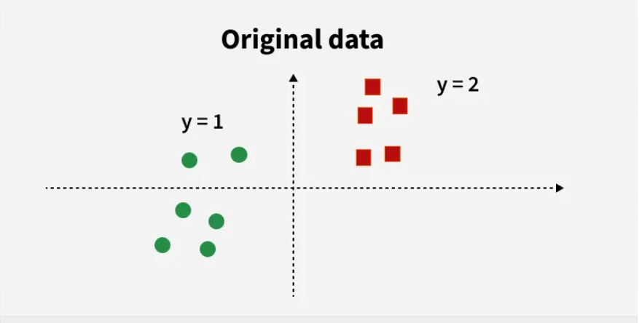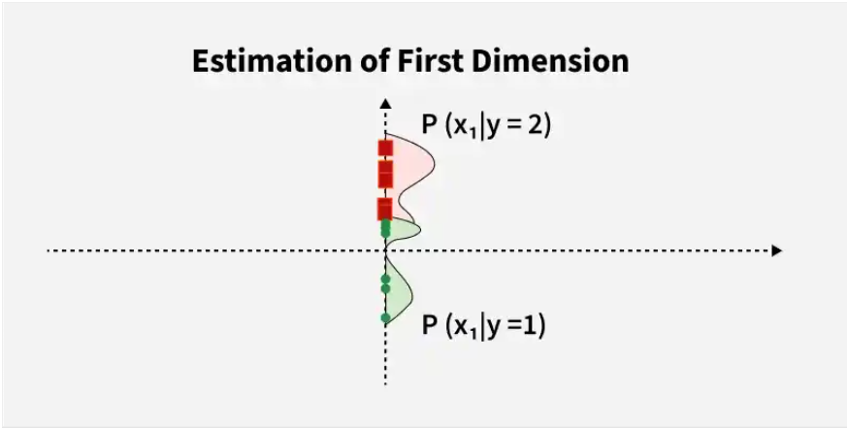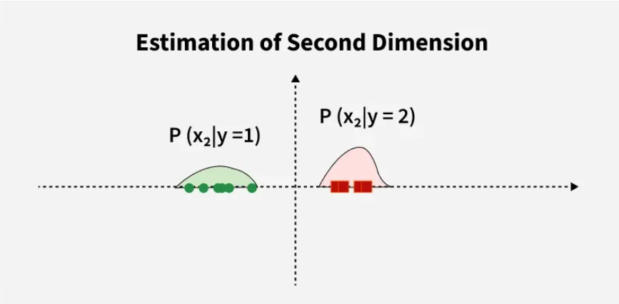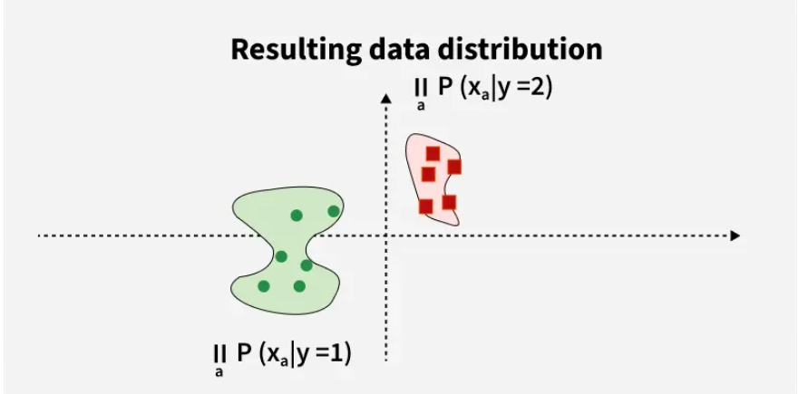

Here,
- Original Data has two classes: green circles(y=1) and red squares(y=2)
- Estimate Probability distribution along first dimension
i.e P(x1​∣y=1),P(x1​∣y=2)
- Estimate probability distribution along the second dimension i.e P(x2∣y=1),P(x2∣y=2)P(x2​∣y=1),P(x2​∣y=2)
- Combine both dimensions using conditional independence i.e P(x∣y)=∏αP(xα∣y)P(x∣y)=∏α​P(xα​∣y)

The main idea behind the Naive Bayes classifier is to use Bayes’ Theorem to classify data based on the probabilities of different classes given the features of the data. It is used mostly in high-dimensional text classification.

It is named as "Naive" because it assumes the presence of one feature does not affect other features. The "Bayes" part of the name refers to its basis in Bayes’ Theorem.

Assumption of Naïve Bayes:
- Feature independence
- Continuous features are normally distributed
- Discrete features has multinomial distributions
- Features are equally important
- No missing data

Bayes’ Theorem:
Bayes’ Theorem provides a principle way to reverse the conditional probabilities.
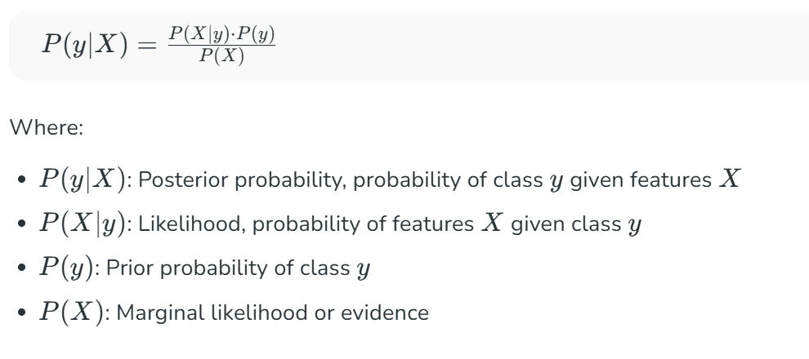
Working of Naive Bayes:
  - Terminology
Consider a classification problem (like predicting if someone plays golf based on weather). Then:
- yy is the class label (e.g. "Yes" or "No" for playing golf)
- X=(x1,x2,...,xn) is the feature vector (e.g. Outlook, Temperature, Humidity, Wind)
Eg. X = (Raniy, Hot, High, False), y = No
This represents what is the probability that someone does not play golf given that the weather is Rainy, Hot, High Humidity and No wind.

  - The Naive Assumption:
The “naïve” in Naïve Bayes’ comes from the assumption that all the features are independent.
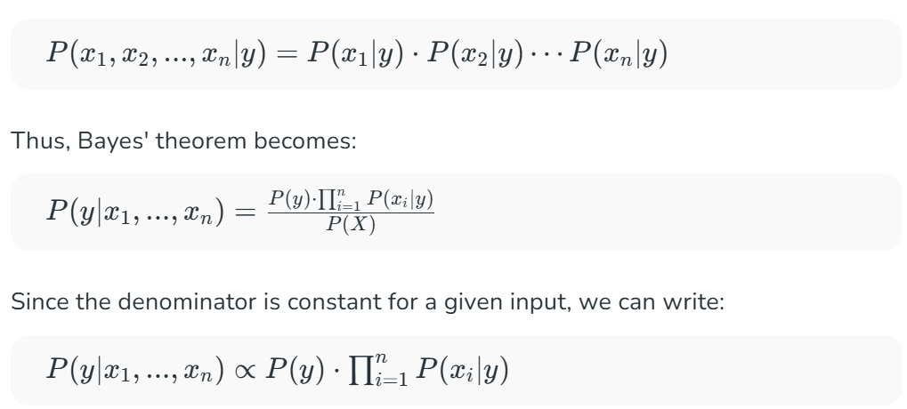
  - Constructing Naive Bayers Classifier:
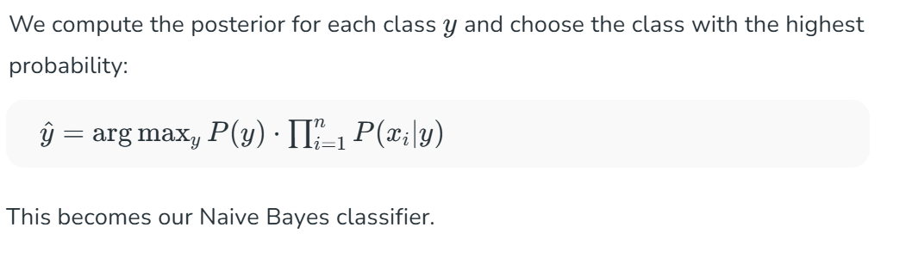
  - Example : Weather Dataset
Let’s take dataset used for predicting if the golf is played based on:
- Outlook: Sunny, Rainy, Overcast
- Temperature: Hot, Mild, Cool
- Humidity: High, Normal
- Wind: True, False
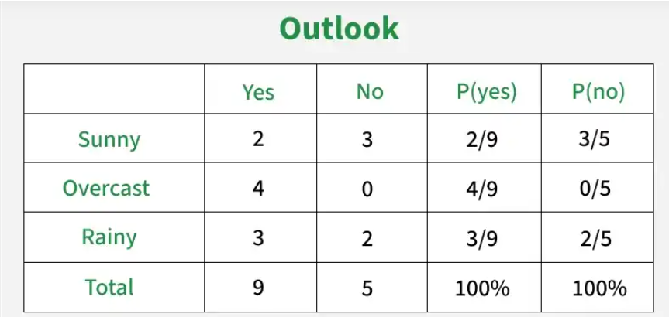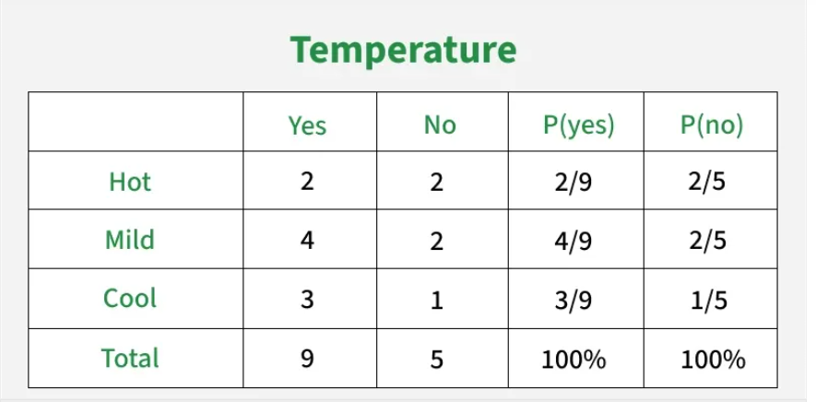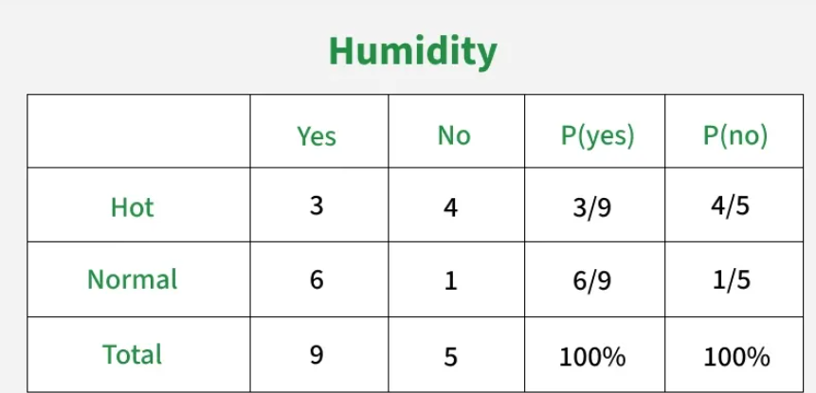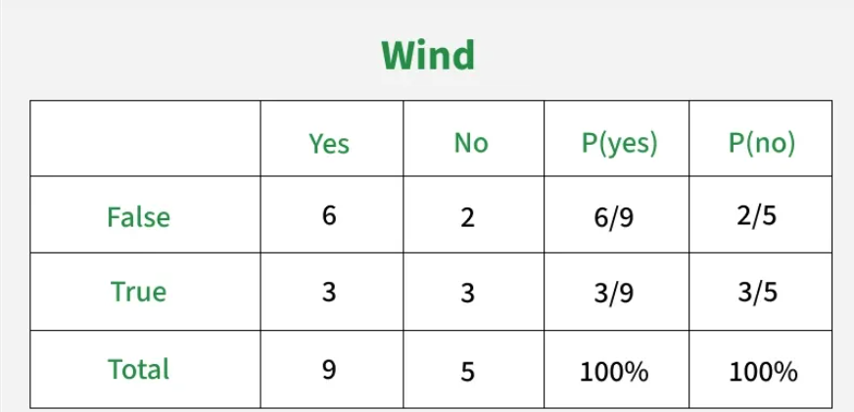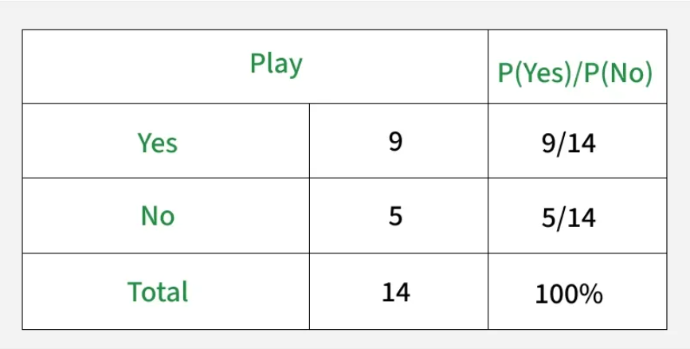

Example: X = (Sunny, Hot, Normal, False)
Goal: Predict if the golf will be played(Yes or No)

  - Pre-computation from Dataset
Class probabilities:
From Dataset of 14 rows,
P( Yes ) = 9/14
P( NO ) = 5/14
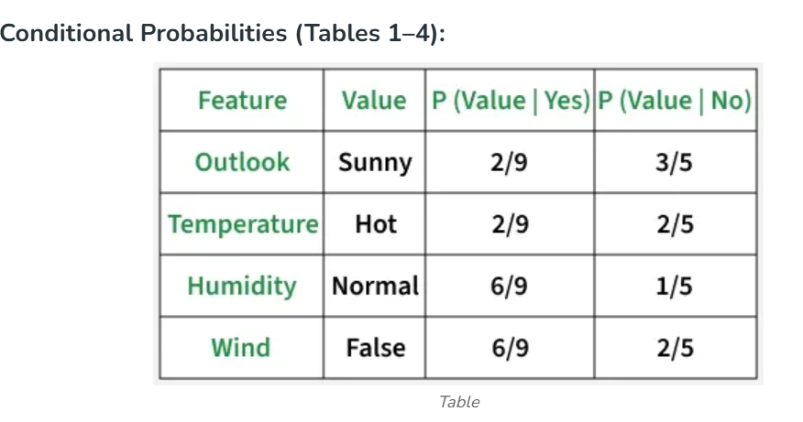
  - Calculate Posterior Probabilities:
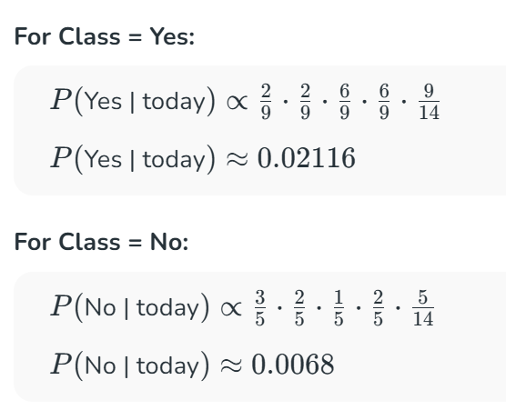
  - Normalize Probabilities:
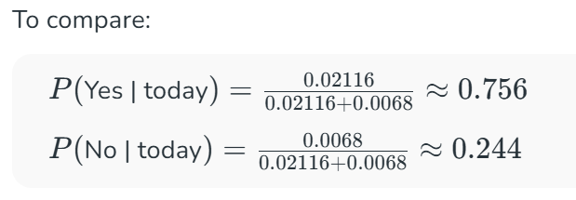

  - Final Prediction:
